

American International University-Bangladesh (AIUB)  
Department of Computer Science  
Faculty of Science &Technology (FST)  
Spring 22-23

Section: G  
Software Quality Assurance and Testing

E-Commerce Site (Daraz)

A Report submitted

By

|  |  |  |
| --- | --- | --- |
| SN | Student Name | Student ID |
| 1 | Anik Kumar Das | 20-43914-2 |
| 2 | Jaber Md.Oasik | 20-42523-1 |
| 3 | Maliha Mehjabin | 20-42508-1 |

Under the supervision of

Farazana Binte Alom

Lecturer, Dept. of CS

Software Test Plan

for

<Daraz>

Version 1.0 approved.

Prepared by <Group-5>

<AIUB>

<26/04/23>

**Checked By Industry Personnel**

Name: **Rifat Alam**

Designation: **Software Quality Assurance Eng.**

Company**: BNX Network**

Sign: 

**\*\*Test Scripts\*\***

**7.Test Cases/Test Items:**

|  |  |  |  |  |  |
| --- | --- | --- | --- | --- | --- |
| Project Name: daraz.com.bd | | | Test Designed by: Anik Kumar Das | | |
| Test Case ID: TC_1 | | | Test Designed date: 24/04/23 | | |
| Test Priority (Low, Medium, High): Medium | | | Test Executed by: Anik Kumar das | | |
| Module Name: Home page all link validation session | | | Test Execution date: 25/04/23 | | |
| Test Title: Check all link on home page | | |  | | |
| Description: Click on the link and go in other page | | |  | | |
| Precondition (If any): | | | | | |
| Test Steps | Test Data | Expected Results | | Actual Results | Status (Pass/Fail) |
| 1. Go to the website 2. Click links |  | The page will change for that link that is clicked | | As expected, | Pass |
| Post Condition: If you need to log in to access a link ,you must log in first | | | | | |

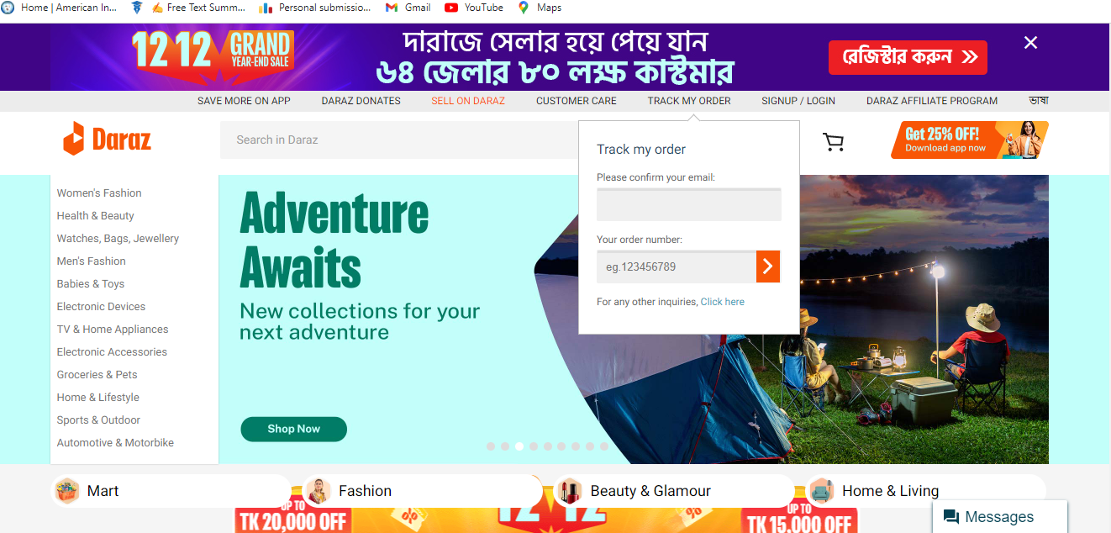

|  |  |  |  |  |  |
| --- | --- | --- | --- | --- | --- |
| Project Name: daraz.com.bd | | | Test Designed by: Anik Kumar Das | | |
| Test Case ID: TC_2 | | | Test Designed date: 24/04/23 | | |
| Test Priority (Low, Medium, High): High | | | Test Executed by: Anik Kumar Das | | |
| Module Name: OTP Check in Seller registration Session | | | Test Execution date: 25/04/23 | | |
| Test Title: Check the verification code send or not | | |  | | |
| Description: Testing the verification code send or not | | |  | | |
| Precondition (If any): The mobile number must be correct and click on the submit button | | | | | |
| Test Steps | Test Data | Expected Results | | Actual Results | Status (Pass/Fail) |
| 1. Go to the website 2. Seller registration 3. Enter Mobile number 4. Click on Create account | Mobile Number:01721736733 | A verification code must go to the given mobile number | | As expected, | Pass |
| Post Condition: The mobile number will not be saved in the database until the total registration is complete | | | | | |

|  |  |  |  |  |  |
| --- | --- | --- | --- | --- | --- |
| Project Name: daraz.com.bd | | | Test Designed by: Jaber Md.oasik | | |
| Test Case ID: TC_3 | | | Test Designed date: 24/04/23 | | |
| Test Priority (Low, Medium, High): High | | | Test Executed by: Jaber Md.oasik | | |
| Module Name: Seller registration Session | | | Test Execution date: 25/04/23 | | |
| Test Title: Register as Seller | | |  | | |
| Description: Seller registration with given all information. | | |  | | |
| Precondition (If any): The mobile number and OTP must be correct | | | | | |
| Test Steps | Test Data | Expected Results | | Actual Results | Status (Pass/Fail) |
| 1. Go to the website 2. Seller registration 3. Enter Mobile number 4. Click on Create account | Mobile Number:01721736733 | After Submit all data show massage Registration successful | | As expected, | Pass |
| Post Condition: All information must be store in data base | | | | | |

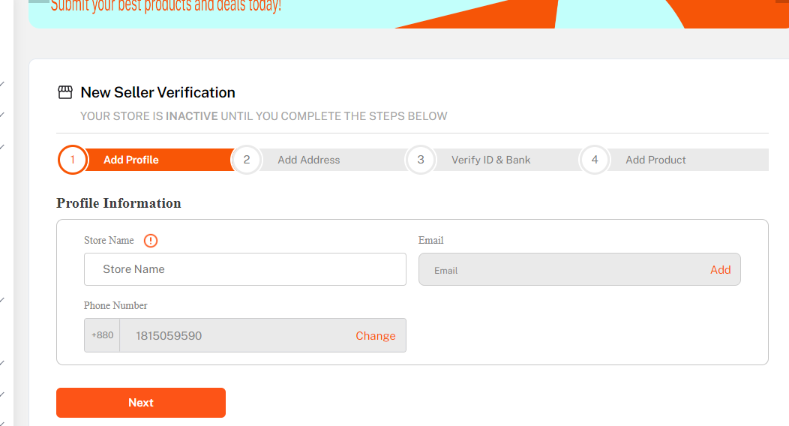

|  |  |  |  |  |  |
| --- | --- | --- | --- | --- | --- |
| Project Name: daraz.com.bd | | | Test Designed by: Anik Kumar Das | | |
| Test Case ID: TC_4 | | | Test Designed date: 24/04/23 | | |
| Test Priority (Low, Medium, High): High | | | Test Executed by: Anik Kumar Das | | |
| Module Name: user registration Session | | | Test Execution date: 25/04/23 | | |
| Test Title: Registration as a User | | |  | | |
| Description: Testing website user registration. | | |  | | |
| Precondition (If any): User must have valid phone number. | | | | | |
| Test Steps | Test Data | Expected Results | | Actual Results | Status (Pass/Fail) |
| 1. Go to the website 2. Login/Signup 3. Register 4. Enter Mobile number 5. Click Submit | Mobile Number:0181505950 | After clicking the submit button show massage registration successful | | Server error, | Fail |
| Post Condition: no login session will create. | | | | | |

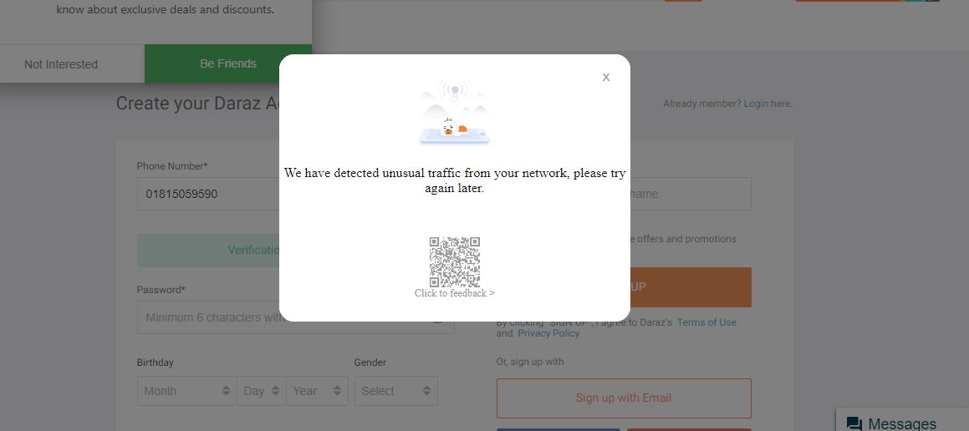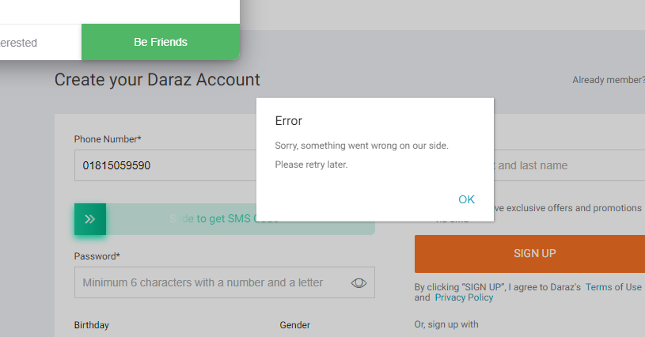

|  |  |  |  |  |  |
| --- | --- | --- | --- | --- | --- |
| Project Name: daraz.com.bd | | | Test Designed by: Jaber Md.oasik | | |
| Test Case ID: TC_5 | | | Test Designed date: 24/04/23 | | |
| Test Priority (Low, Medium, High): Low | | | Test Executed by: Jaber Md.oasik | | |
| Module Name: User login Validation Session | | | Test Execution date: 25/04/23 | | |
| Test Title: Verification of input data in the login page | | |  | | |
| Description: Testing website user login page. | | |  | | |
| Precondition (If any): User must have valid phone number and password. | | | | | |
| Test Steps | Test Data | Expected Results | | Actual Results | Status (Pass/Fail) |
| 1. Go to the website 2. Login/Signup 3. Click Login | Mobile Number:01721736733 | After clicking the submit button error massage will be shown for all field that it needs values.. | | As expected, | Pass |
| Post Condition: no login session will create. | | | | | |

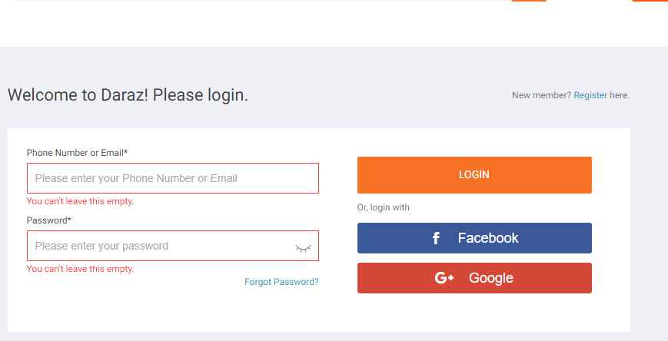

|  |  |  |  |  |  |
| --- | --- | --- | --- | --- | --- |
| Project Name: daraz.com.bd | | | Test Designed by: Anik Kumar Das | | |
| Test Case ID: TC_6 | | | Test Designed date: 24/03/23 | | |
| Test Priority (Low, Medium, High): Medium | | | Test Executed by: Anik Kumar Das | | |
| Module Name: User login Session | | | Test Execution date: 25/04/23 | | |
| Test Title: User login | | |  | | |
| Description: Testing website user login page. | | |  | | |
| Precondition (If any): User must have valid phone number and password. | | | | | |
| Test Steps | Test Data | Expected Results | | Actual Results | Status (Pass/Fail) |
| 1. Go to the website 2. Seller registration 3. Enter Email and password 4. Click on Login | Mobile  Email:anikkumardas966@gmail.com  Pass: anik066 | After clicking the Login button user login successfully | | As expected, | Pass |
| Post Condition: All information must be store in data base | | | | | |

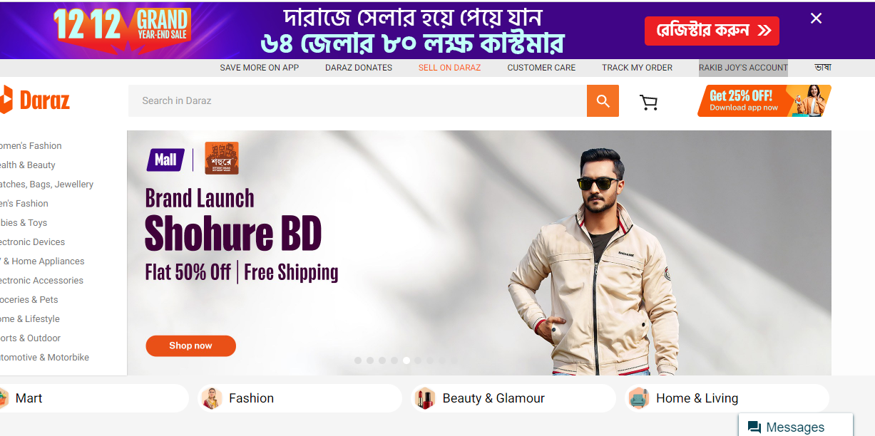

|  |  |  |  |  |  |
| --- | --- | --- | --- | --- | --- |
| Project Name: daraz.com.bd | | | Test Designed by: Jaber Md.oasik | | |
| Test Case ID: TC_7 | | | Test Designed date: 24/04/23 | | |
| Test Priority (Low, Medium, High): High | | | Test Executed by Jaber Md.oasik | | |
| Module Name: Forgot password session | | | Test Execution date: 25/04/23 | | |
| Test Title: Reset the password | | |  | | |
| Description: Testing website Forgot password. | | |  | | |
| Precondition (If any): User must provide valid phone number or email. | | | | | |
| Test Steps | Test Data | Expected Results | | Actual Results | Status (Pass/Fail) |
| 1. Go to the website 2. Login/Signup 3. Go Forgot Password | Email Number: anikkumardas966@gmail.com | Reset the password | | Server error, | Fail |
| Post Condition: No Data change in Data Base | | | | | |

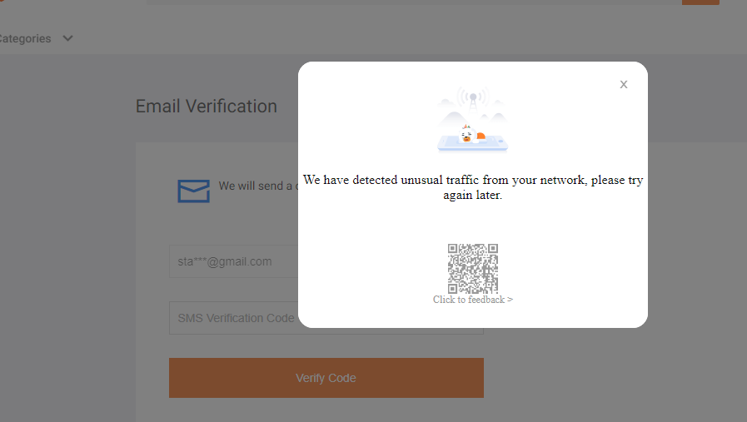

|  |  |  |  |  |  |
| --- | --- | --- | --- | --- | --- |
| Project Name: daraz.com.bd | | | Test Designed by: Maliha Mehjabin | | |
| Test Case ID: TC_8 | | | Test Designed date: 24/04/23 | | |
| Test Priority (Low, Medium, High): Low | | | Test Executed by: Maliha Mehjabin | | |
| Module Name: Edit profile session | | | Test Execution date: 25/04/23 | | |
| Test Title: Edit user Personal profile | | |  | | |
| Description: Testing Edit user Personal profile. | | |  | | |
| Precondition (If any): User must Login. | | | | | |
| Test Steps | Test Data | Expected Results | | Actual Results | Status (Pass/Fail) |
| 1. Go to the website 2. Login/Signup 3. Login 4. Account 5. Manage My Account 6. Edit Personal Account | Name :anikkumardas966@gmail.com | Edit data Change Successfully | | As Expected, | Pass |
| Post Condition: Edit Data will change in Data base | | | | | |

|  |  |  |  |  |  |
| --- | --- | --- | --- | --- | --- |
| Project Name: daraz.com.bd | | | Test Designed by: Anik Kumar Das | | |
| Test Case ID: TC_9 | | | Test Designed date: 24/04/23 | | |
| Test Priority (Low, Medium, High): Low | | | Test Executed by: Anik Kumar Das | | |
| Module Name: Change Password session | | | Test Execution date: 25/04/23 | | |
| Test Title: User Password Change | | |  | | |
| Description: Testing User Password Change. | | |  | | |
| Precondition (If any): User must Login. | | | | | |
| Test Steps | Test Data | Expected Results | | Actual Results | Status (Pass/Fail) |
| 1. Go to the website 2. Login/Signup 3. Login 4. Account 5. Manage My Account 6. Edit Account 7. Change password | Name :anik kumar das | Change password Successfully | | As Expected, | Pass |
| Post Condition: Edit Data will change in Data base | | | | | |

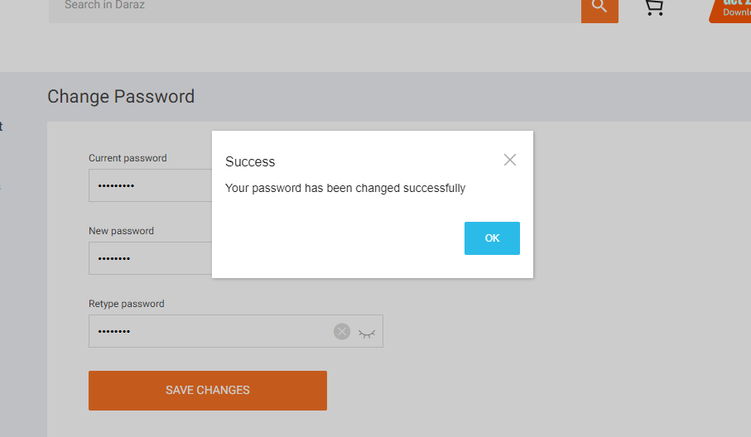

|  |  |  |  |  |  |
| --- | --- | --- | --- | --- | --- |
| Project Name: daraz.com.bd | | | Test Designed by: Maliha Mehjabin | | |
| Test Case ID: TC_10 | | | Test Designed date: 24/04/23 | | |
| Test Priority (Low, Medium, High): High | | | Test Executed by: Maliha Mehjabin | | |
| Module Name: Add cart session | | | Test Execution date: 25/04/23 | | |
| Test Title: Add cart product for buy | | |  | | |
| Description: Testing cart product. | | |  | | |
| Precondition (If any): User must Login. | | | | | |
| Test Steps | Test Data | Expected Results | | Actual Results | Status (Pass/Fail) |
| 1. Go to the website 2. Login 3. Product list 4. Add Cart | No Input | Cart Successfully | | As Expected, | Pass |
| Post Condition: Update all database for the cart product | | | | | |

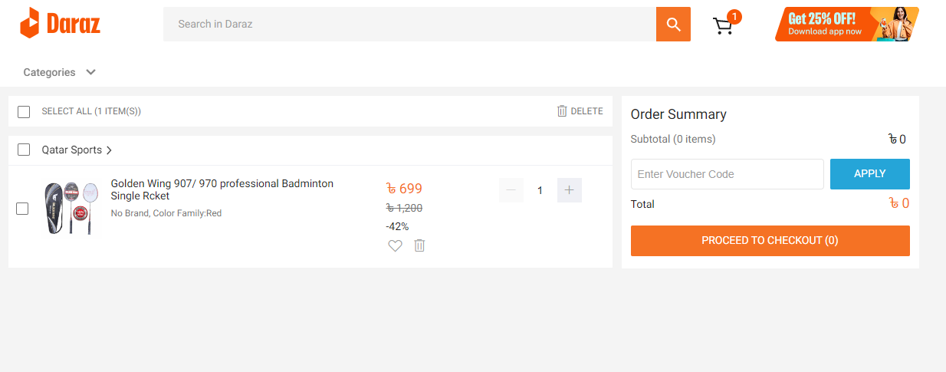

|  |  |  |  |  |  |
| --- | --- | --- | --- | --- | --- |
| Project Name: daraz.com.bd | | | Test Designed by: Jaber Md.oasik | | |
| Test Case ID: TC_11 | | | Test Designed date: 24/04/23 | | |
| Test Priority (Low, Medium, High): Medium | | | Test Executed by: Jaber Md.oasik | | |
| Module Name: Remove cart session | | | Test Execution date: 25/04/23 | | |
| Test Title: Remove cart product for buy | | |  | | |
| Description: Testing Remove cart product. | | |  | | |
| Precondition (If any): User must be Login. | | | | | |
| Test Steps | Test Data | Expected Results | | Actual Results | Status (Pass/Fail) |
| 1. Go to the website 2. Login 3. Product list 4. Add Cart | No Input | Remove Cart Successfully | | As Expected, | Pass |
| Post Condition: Update all database for the Remove cart product | | | | | |

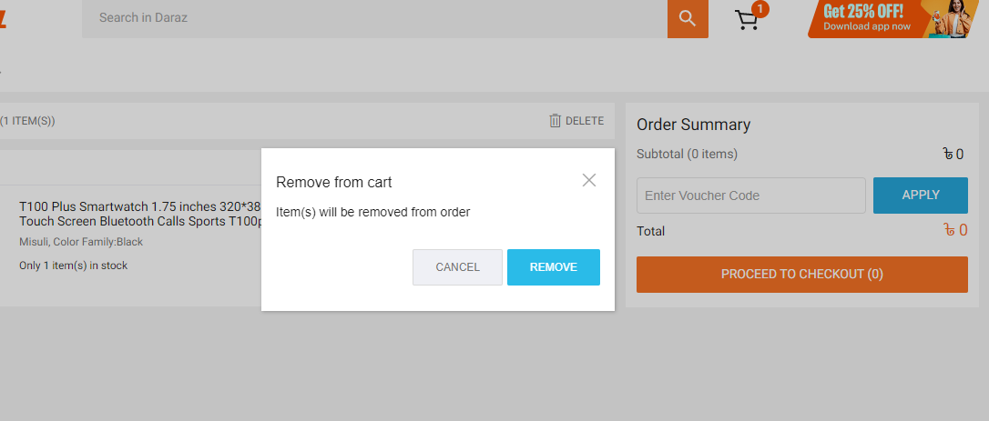

|  |  |  |  |  |  |
| --- | --- | --- | --- | --- | --- |
| Project Name: daraz.com.bd | | | Test Designed by: Maliha Mehjabin | | |
| Test Case ID: TC_12 | | | Test Designed date: 24/04/23 | | |
| Test Priority (Low, Medium, High): Medium | | | Test Executed by: Maliha Mehjabin | | |
| Module Name: Abuse session | | | Test Execution date: 25/04/23 | | |
| Test Title: Check abuse report submission | | |  | | |
| Description: Testing abuse report submission. | | |  | | |
| Precondition (If any): User must be Login. | | | | | |
| Test Steps | Test Data | Expected Results | | Actual Results | Status (Pass/Fail) |
| 1. Go to the website 2. Login 3. Product list 4. Comment Section 5. Report | comments | Report submission complete. | | As Expected, | Pass |
| Post Condition: No duplicate report submission for same product. | | | | | |

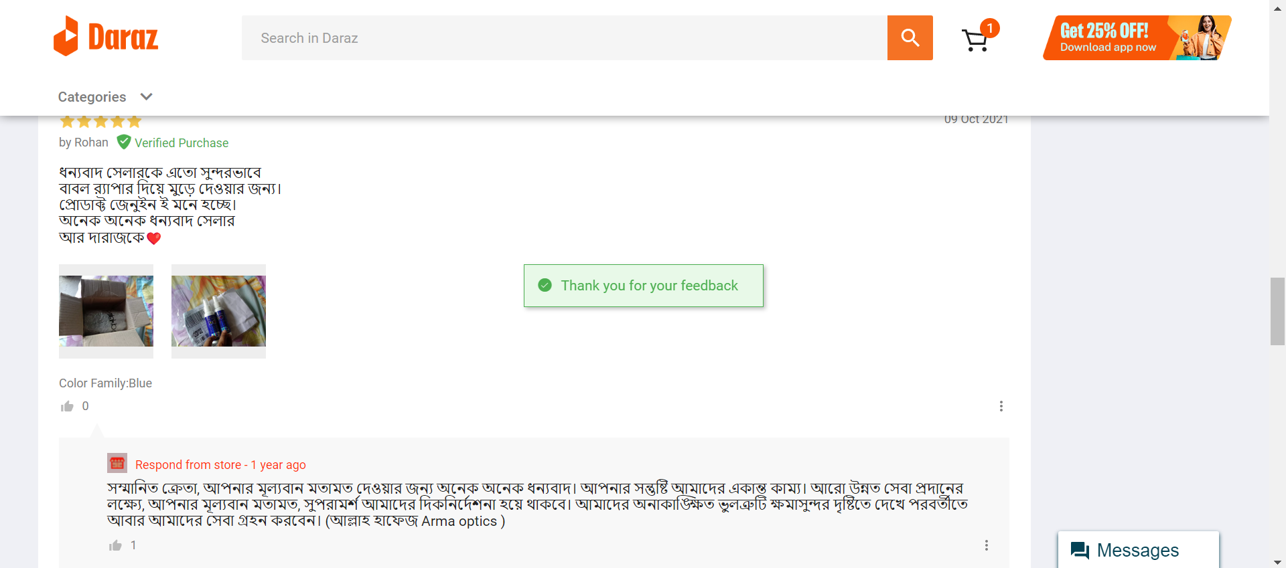

|  |  |  |  |  |  |
| --- | --- | --- | --- | --- | --- |
| Project Name: daraz.com.bd | | | Test Designed by: Jaber Md.oasik | | |
| Test Case ID: TC_13 | | | Test Designed date: 24/04/23 | | |
| Test Priority (Low, Medium, High): High | | | Test Executed by: Jaber Md.oasik | | |
| Module Name: Coupon verification session | | | Test Execution date: 25/04/23 | | |
| Test Title: Check Coupon verification | | |  | | |
| Description: Testing if the Coupon is validate before ordering. | | |  | | |
| Precondition (If any): User must be Login. | | | | | |
| Test Steps | Test Data | Expected Results | | Actual Results | Status (Pass/Fail) |
| 1. Go to the website 2. Login 3. View cart 4. Apply Wrong Coupon | No Input | Add coupon voucher is not validate | | As Expected, | Pass |
| Post Condition: No data update in database | | | | | |

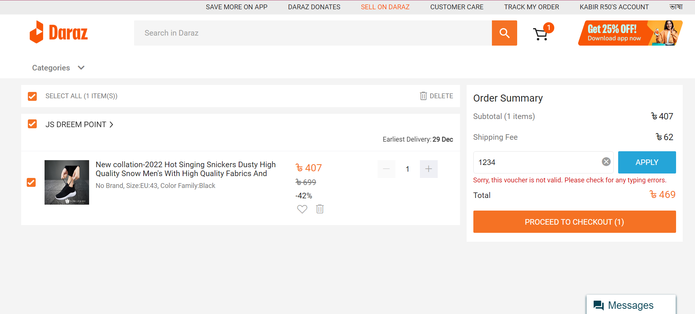

**Java Code**

import org.openqa.selenium.By;  
import org.openqa.selenium.chrome.ChromeDriver;  
  
public class Main {  
public static void main(String[] args) {  
System.out.println("Hello world!");  
System.setProperty("webdriver.chrome.driver", "C:\\BrowserDriver\\chromedriver.exe");  
ChromeDriver driver=new ChromeDriver();  
  
driver.get("https://stackoverflow.com/users/login?ssrc=head&returnurl=https%3a%2f%2fstackoverflow.com%2f");  
  
driver.manage().window().maximize();  
  
driver.findElement(By.id("email"))  
.sendKeys("zhoasik999@gmail.com");  
  
driver.findElement(By.id("password"))  
.sendKeys("oasik999");  
driver.findElement(By.id("submit-button")).click();  
  
  
// driver.quit();  
  
  
}  
}

**Picture:**

